Homework 2
Austin Bennett

Q. 1) UNIX systems typically handle orphan processes by assigning them to the init process (usually PID 1), which acts as the parent of last resort. The init process reaps these orphaned child processes and ensures they do not become zombie processes.

Q. 2) i&k are in the stack, *str is a pointer located on the stack and it points to a character array in the heap, j is located in the stack, ptr is in the stack, ptr[0] is in the heap, buf is on the stack, and y is in the BSS.

Q. 3) No, it is essential for multitasking as the CPU couldn’t allocate time properly between processes.

Q. 4) It allows processes to not know exact ID or location. This helps with scaling and management.

Q. 5)
1. fork() | This creates the new processes
2. execlp("/bin/ls", "ls", NULL); | This will replacet he child’s process memory with ls.

Q. 6)
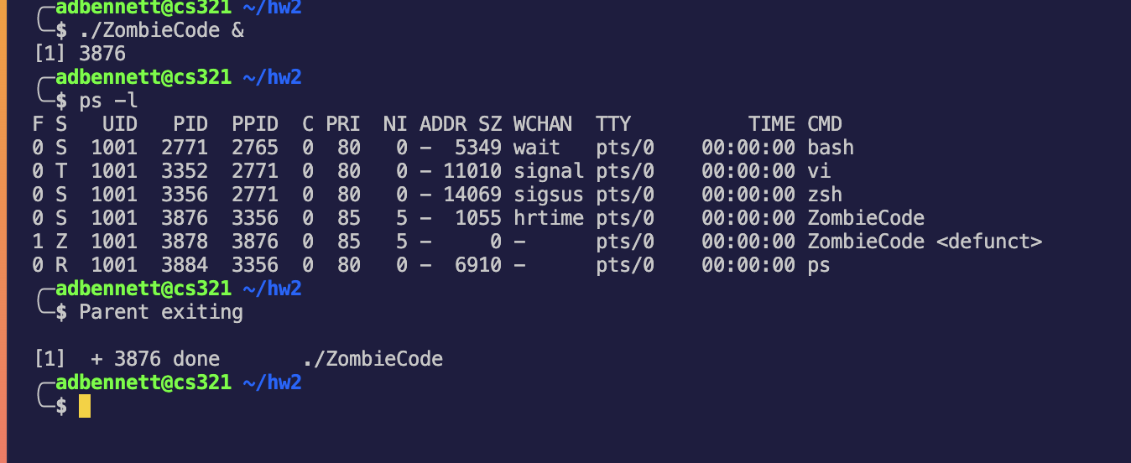

Q. 7)


